(Header)  
Logo **(Will share from our end)** Ad Formats --- Advantages --- About us --- Contact Us

__________________________________________________________________________________________________

1. **HomePage**  
   Text To be added (Element’s relating to tech work) – **Below are some reference we are expecting.**

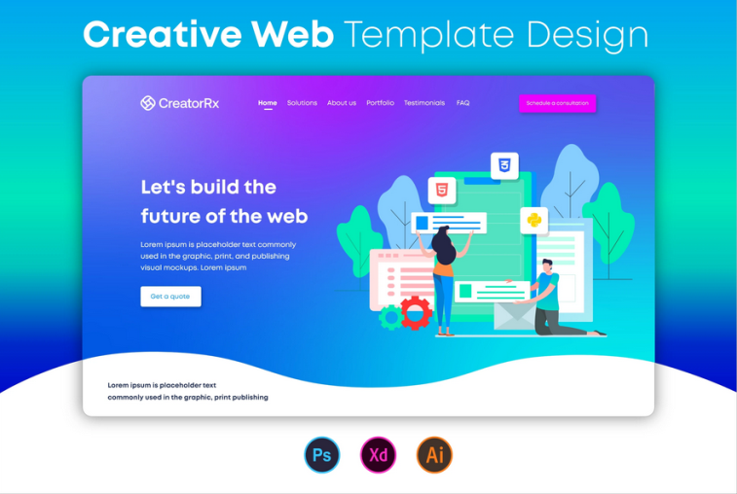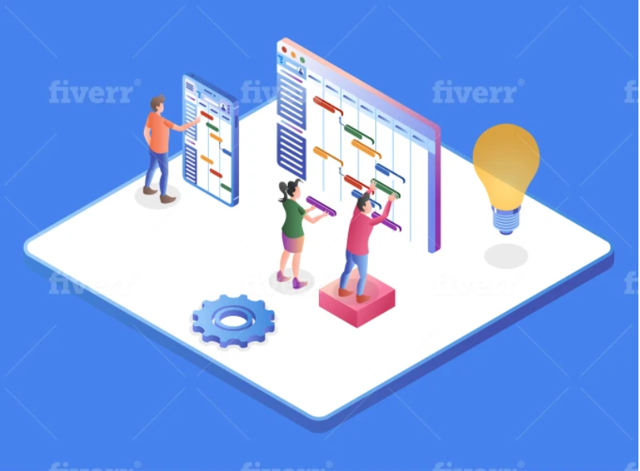

__________________________________________________________________________________________________

1. AdFormats – Sub Titles **(are some reference we are expecting.)**
2. Display – MobileApp & PC (Elements)
3. Native - MobileApp & PC (Elements)
4. Video - MobileApp & PC (Elements)
5. Connected TV - MobileApp & PC (Elements)

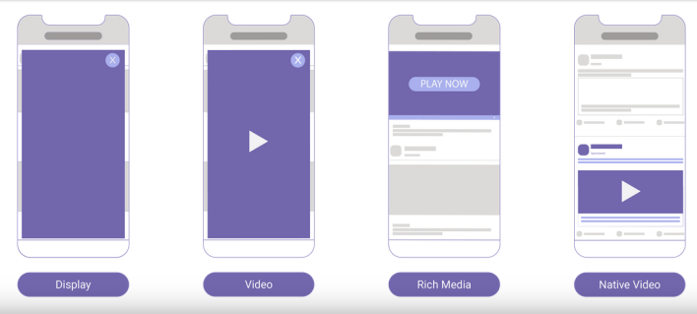 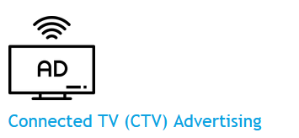 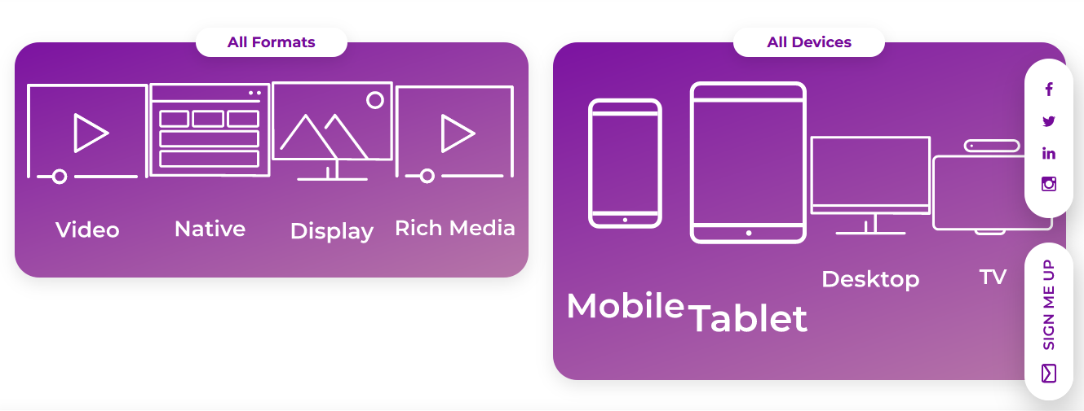  
___________________________________________________________________________________________

1. Advantages – Sub Title
2. Ad Optimization - Elements
3. Real Time Bidding – Elements
4. Quality Traffic - Elements
5. Global Reach - Elements
6. Easy Integration - Elements
7. Dedicated Account Manager - Elements
8. Reporting Api – Elements

_________________________________________________________________________________________________

1. Verticals – Sub Title
2. Utilities – Elements
3. Gaming – Elements
4. LifeStyle – Elements
5. E-commerce – Elements
6. Finance – Elements
7. Health & Fitness – Elements
8. Education – Elements
9. Society – Elements

__________________________________________________________________________________________________

1. Scroll & Tap Events:

Will be visiting soon (At the Bold Letters)

__________________________________________________________________________________________________

1. About us:

__________________________________________________________________________________________________

1. Contact us Page (Elements)

First Name: Last name

Email id:

Telephone / Mobile Number:

Subject:

Message Body: (Text Box)

Send: (Action Button)

__________________________________________________________________________________________________

(Footer)

1. Company Logo – (**Will share from our end**)
2. All Section Subtitles to be added in the footer.

HomePage --- Adformats --- Advantages --- Verticals --- Scroll & Tap Events --- About us --- Contact Us.

__________________________________________________________________________________________________

Privacy Policy --- Terms & Conditions --- Opt out